- 
Normalizing and Denormalizing Data | Chapter 3

After designing a database, it is important to ensure that the data in the tables is consistent and relevant. Normalization is a process of reducing duplicate data in a relational database. The opposite of normalization is called as denormalization.
This chapter explains the process of normalizing a database. It discusses the various types of normal forms: first normal form, second normal form, third normal form, and Boyce-Codd Normal Form (BCNF). In addition, the chapter discusses about denormalization.
Objectives
In this chapter, you will learn to:
- Describe data redundancy
- Appreciate the need for denormalization

Understanding Data Redundancy
Redundancy means repetition of data. Redundancy increases the time involved in updating, adding, and deleting data. It also increases the utilization of disk space and hence, disk I/O increases.
Consider the following STUDENT table.
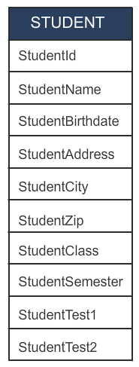

The STUDENT Table

The STUDENT table contains the values for each attribute, as shown in the following table.

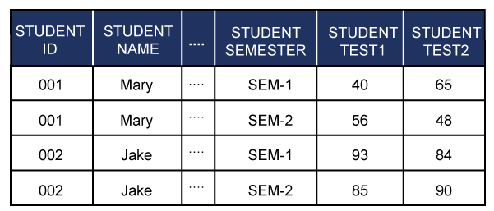
Values in the STUDENT Table
In the preceding table, the details of the students, such as STUDENTID, STUDENTNAME, and STUDENTADDRESS are repeated while recording marks of different semesters. In addition, if you need to modify the address of a student, it has to be modified in multiple rows for that student. If not done, it could lead to data inconsistency across rows. If there are 1000 students and the details for each student occupy 200 bytes, then 200,000 bytes are repeated. Hence, a lot of disk space is used up unnecessarily.
Redundancy can, therefore, lead to:
- Insertion, modification, and deletion of data, which may cause inconsistencies.
- Errors, which are more likely to occur when facts are repeated.
- Unnecessary utilization of extra disk space.
You can use systematic approaches like normalization to reduce redundancy.

Definition of Normalization
Normalization is a method of breaking down complex table structures into simple table structures by using certain rules. Using this method, you can reduce redundancy in a table, and eliminate the problems of inconsistency and disk space usage. You can also ensure that there is no loss of information.
Normalization has the following benefits:
- It helps in maintaining data integrity.
- It helps in simplifying the structure of tables, therefore, making a database more compact.
- It helps in reducing the null values, which reduces the complexity of data operations.
The performance of an application is directly linked to the database design. A poor design results in poor performance of the system. The logical design of the database lays the foundation for an optimal database.
Some rules that should be followed to achieve a good database design are:
- Each table should have a unique identifier.
- Each table should store data for a single type of entity.
- Columns that accept NULL values should be avoided.
- The repetition of values or columns should be avoided.
Normalization results in the formation of tables that satisfy certain specified rules and represent certain normal forms. The normal forms are used to ensure that various types of abnormalities and inconsistencies are not introduced in the database. A table structure is always in a certain normal form. Several normal forms have been identified. The most important and widely used normal forms are:
- First Normal Form (1NF)
- Second Normal Form (2NF)
- Third Normal Form (3NF)
- Boyce-Codd Normal Form (BCNF)
The following diagram shows the different levels of normalization.
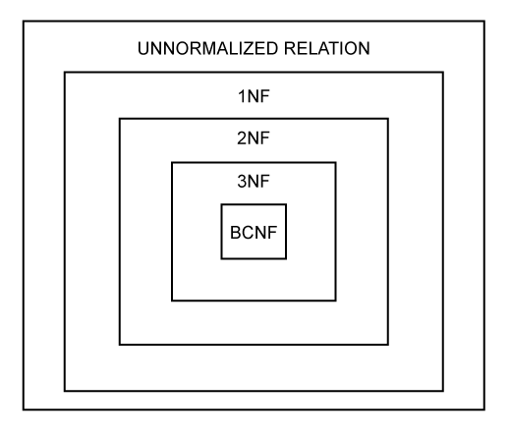
The Different Levels of Normalization
The first, second, and third normal forms were originally defined by Dr. E. F. Codd. Later, Boyce and Codd introduced another normal form called the Boyce-Codd Normal Form.
First Normal Form
A table is said to be in 1NF when each cell of the table contains precisely one value.
Guidelines for Converting a Table to 1NF
The guidelines for converting a table to 1NF are:
- Place the related data values in a table. Further, define similar data values with the column name.
- There should be no repeating group in the table.
- Every table must have a unique primary key.
Consider the following PROJECT table.
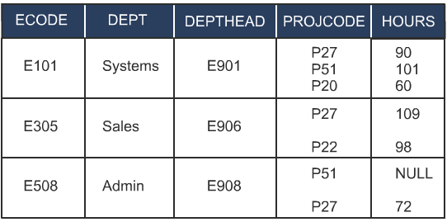

The PROJECT Table
The preceding table already satisfies the two guidelines of the first normal form. The values in the PROJECT table are related, and similar data values have been defined by the common attribute name. The PROJECT table also has a primary key, ECODE, which uniquely defines the complete table. However, the data in the PROJECT table is still not in first normal form because the cells in PROJCODE and HOURS have more than one value. By applying 1NF definition to the PROJECT table, you arrive at the following table.
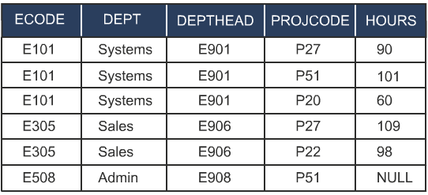
The PROJECT Table in 1NF
Now, consider the following STUDENT table.
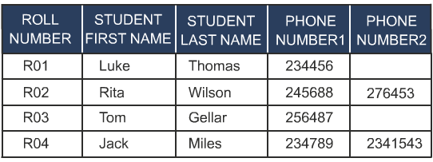
The STUDENT Table in 1NF
The preceding table gives the details of students. Consider the following points about the STUDENT table:
- It consists of student roll number (ROLL NUMBER), student first name (STUDENT FIRST NAME), student last name (STUDENT LAST NAME), and student residential phone numbers (PHONE NUMBER1 and PHONE NUMBER2).
- It has a primary key, ROLL NUMBER, which uniquely defines the complete table.
The preceding table satisfies the two guidelines of first normal form. However, it does contain null values and the number of telephone numbers per student is restricted to two. If a student has three telephone numbers, you are constrained to record only two and leave the third unrecorded. This means that the database design is imposing constraints on recording data in the tables. Therefore, there is a need of normalizing the STUDENT table.
By applying 1NF definition to the STUDENT table, you can arrive at the following tables.

ROLL NUMBER | STUDENT FIRST NAME | STUDENT LAST NAME
R01 | Luke | Thomas
R02 | Rita | Wilson
R03 | Tom | Gellar
R04 | Jack | Miles

ROLL NUMBER | PHONE NUMBER
R01 | 234456
R02 | 245688
R02 | 276453
R03 | 256487
R04 | 234789
R04 | 2341543
The Tables in 1NF
Now, to convert the table to 2NF, you must first understand the concept of functional dependency.
Functional Dependency
The normalization theory is based on the fundamental notion of functional dependency. Given a relation (you may recall that a table is also called a relation) R, attribute A is functionally dependent on attribute B if each value of A in R is associated with precisely one value of B.
In other words, attribute A is functionally dependent on B if and only if, for each value of B, there is exactly one value of A.
Attribute B is called the determinant.
Consider the following REPORT table.

The REPORT Table
The preceding table has a composite key (ROLL_NUMBER+COURSE_CODE).
In the preceding table, for a particular value of ROLL_NUMBER+COURSE_CODE, there is precisely one corresponding value for MARKS. Hence, MARKS is functionally dependent on ROLL_NUMBER+COURSE_CODE. This can be symbolically represented as (ROLL_NUMBER, COURSE_CODE) → MARKS.
The following diagram shows the functional dependency between MARKS and ROLL_NUMBER+COURSE_CODE.
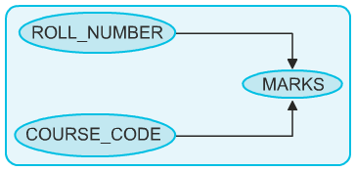
The Functional Dependency
The other functional dependencies in the preceding table are:
- COURSE_CODE→COURSE_NAME
- COURSE_CODE→T_NAME (Assuming one course is taught by only one
teacher.)
- T_NAME→ROOM_NUMBER (Assuming each teacher has his/her own, unshared room.)
- MARKS→GRADE
- COURSE_CODE→ROOM_NUMBER
Further, the attribute COURSE_NAME is not functionally dependent on ROLL_NUMBER+COURSE_CODE. It is only dependent on COURSE_CODE. Similarly, T_NAME and ROOM_NUMBER are not functionally dependent on the whole key. T_NAME and ROOM_NUMBER are only dependent on COURSE_CODE. Therefore, COURSE_NAME, T_NAME, and ROOM_NUMBER attributes are partially dependent on the whole key. This dependency is called partial dependency, as shown in the following diagram.
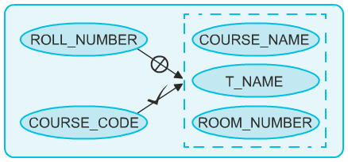
The Partial Dependency
In the preceding diagram, ROOM_NUMBER is dependent on T_NAME, and T_NAME is dependent on COURSE_CODE. Therefore, ROOM_NUMBER is dependent on COURSE_CODE. This type of dependency is called transitive (indirect) dependency. The following diagram shows the transitive dependency.

The Transitive Dependency

Second Normal Form
A table is said to be in 2NF when:
- It is in 1NF.
- No partial dependency exists between non-key attributes and key attributes.

Guidelines for Converting a Table to 2NF
The guidelines for converting a table to 2NF are:
- Find and remove attributes that are functionally dependent on only a part of the key and not on the whole key. Place them in a different table.
- Group the remaining attributes.
Consider the following Project table.
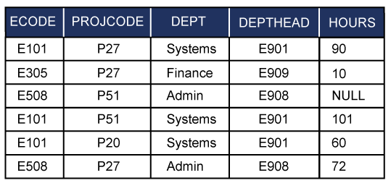 The PROJECT Table
The preceding table could lead to the following problems:
- Insertion: The department of a particular employee cannot be recorded until the employee is assigned a project.
- Updation: For a given employee, the employee code (ECODE), the department name (DEPT), and the department head (DEPTHEAD) are repeated several times. Hence, if an employee is transferred to another department, the change will have to be recorded in every row of the Employee table. Any omission will lead to inconsistencies.
- Deletion: When an employee completes work on a project, the employee’s record is deleted. The information regarding the department to which the employee belongs will also be lost.
The primary key of the preceding table is composite (ECODE+PROJCODE). The table satisfies the definition of 1NF. You need to check now if it satisfies 2NF by considering the following points:
- For each value of ECode, there is more than one value of Hours. For example, for ECode, E101, there are three values of Hours - 90, 101, and 60. Hence, Hours is not functionally dependent on ECode.
- For each value of ProjCode, there is more than one value of Hours. For example, for ProjCode P27, there are three values of Hours - 90, 10, and 72. Hence, Hours is not functionally dependent on ProjCode.
- For a combination of the ECode and ProjCode values, there is exactly one value of Hours. Hence, Hours is functionally dependent on the whole key, ECode+ProjCode.
Now, consider the following points to check if Dept is functionally dependent on the whole key, ECode+ProjCode:
- For each value of ECode, there is exactly one value of Dept. For example, for ECode, E101, there is exactly one value, the Systems department. Hence, Dept is functionally dependent on ECode.
- For each value of ProjCode, there is more than one value of Dept. For example, ProjCode, P27 is associated with two values of Dept, Systems and Finance. Hence, Dept is not functionally dependent on ProjCode.
Therefore Dept is functionally dependent on part of the key, which is ECode, and not functionally dependent on the whole key, ECode+ProjCode.
Similarly, DEPTHEAD is functionally dependent on ECODE; however, it is not dependent on the attribute, PROJCODE. Therefore, the Project table is not in 2NF. For the table to be in 2NF, the non-key attributes must be functionally dependent on the whole key and not part of the key.
To convert the Project table into 2NF, you must remove the attributes that are not functionally dependent on the whole key. You should place the removed attributes in a different table along with the attribute they are functionally dependent on.
In the preceding example, Dept is not functionally dependent on the whole key, ECode+ProjCode. Therefore, you should place Dept along with ECode in a separate table called EmployeeDept. You should also move the DeptHead to the EmployeeDept table. Now, the Project table will contain ECode, ProjCode and Hours.

The following tables are in 2NF.
EMPLOYEEDEPT |  |  |  | PROJECT
ECODE | DEPT | DEPTHEAD |  | ECODE | PROJCODE | HOURS
E101 | Systems | E901 |  | E101 | P27 | 90
E305 | Finance | E909 |  | E101 | P51 | 101
E508 | Admin | E908 |  | E101 | P20 | 60
 |  |  |  | E305 | P27 | 10
 |  |  |  | E508 | P51 | NULL
 |  |  |  | E508 | P27 | 72
The Tables in 2NF
Now, consider the following STUD_SUBJECT_DETAILS table.
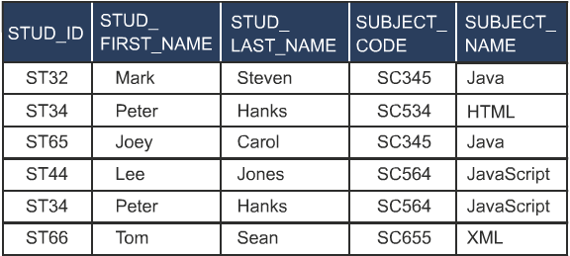
The STUD_SUBJECT_DETAILS Table
The preceding table gives the details of the subjects chosen by a student. Consider the following points about the STUD_SUBJECT_DETAILS table:
- The primary key of the preceding table is STUD_ID + SUBJECT_CODE.
- There are repeated values in columns, STUD_FIRST_NAME, STUD_LAST_NAME, and SUBJECT_NAME. Further, these attributes are dependent on only part of the primary key.
- The values in columns STUD_FIRST_NAME and STUD_LAST_NAME are dependent on STUD_ID.
- The values in SUBJECT_NAME are only dependent on SUBJECT_CODE, and all the non-primary fields are not functionally dependent on the whole primary key.
Therefore, to normalize the table in 2NF, you need to break the table into smaller tables.
The following tables are in 2NF.
STUD_DETAILS
STUD_ID | STUD_FIRST_NAME | STUD_LAST_NAME
ST32 | Mark | Steven
ST34 | Peter | Hanks
ST65 | Joey | Carol
STUD_ID | STUD_FIRST_NAME | STUD_LAST_NAME
ST44 | Lee | Jones
ST66 | Tom | Sean

SUBJECT_DETAILS
SUBJECT_CODE | SUBJECT_NAME
SC345 | Java
SC534 | HTML
SC564 | JavaScript
SC655 | XML

STUD_SUBJECT_DETAILS
STUD_ID | SUBJECT_CODE
ST32 | SC345
ST34 | SC534
ST65 | SC345
ST44 | SC564
ST34 | SC564
ST66 | SC655
The Tables in 2NF

Third Normal Form
A relation is said to be in 3NF if and only if:
- It is in 2NF.
- No transitive (indirect) dependency exists between non-key attributes and key attributes.
Guidelines for Converting a Table to 3NF
The guidelines for converting a table to 3NF are:
- Find and remove non-key attributes that are functionally dependent on attributes that are not the primary key. Place them in a different table.
- Group the remaining attributes.

Consider the following EMPLOYEE table.

EMPLOYEE
ECODE | DEPT | DEPTHEAD
E101 | Systems | E901
E305 | Finance | E909
E402 | Sales | E906
E508 | Admin | E908
E607 | Finance | E909
E608 | Finance | E909
The EMPLOYEE Table
The preceding table could lead to the following problems:
- Insertion: The department head of a new department that does not have any employees at present cannot be entered in the DEPTHEAD column. This is because the primary key is unknown.
- Updation: For a given department, the code for a particular department head (DEPTHEAD) is repeated several times. Hence, if a department head moves to another department, the change will have to be made consistently across the table.
- Deletion: If the record of an employee is deleted, the information regarding the head of the department will also be deleted. Hence, there will be a loss of information.
The EMPLOYEE table contains a single value in each cell. Therefore, the table is in 1NF.
The primary key in the Employee table is ECode. For each value of ECode, there is exactly one value of Dept. Hence, the Dept attribute is functionally dependent on the primary key, ECode. Similarly, for each value of ECode, there is exactly one value of DeptHead. Therefore, DeptHead is functionally dependent on the primary key, ECode. Hence, all the attributes are functionally dependent on the whole key, ECode. Hence, the table is in 2NF.
However, the attribute DeptHead is dependent on the attribute Dept also. As per 3NF, all non-key attributes have to be functionally dependent only on the primary key. This table is not in 3NF since DeptHead is functionally dependent on DEPT, which is not a primary key.
To convert the Employee table into 3NF, you must remove the DeptHead column because it is not functionally dependent on only the primary key, ECODE. You should place DeptHead in another table called DEPARTMENT along with the attribute, DEPT.
The following tables are in 3NF.

EMPLOYEE |  |  | DEPARTMENT
ECODE | DEPT |  | DEPT | DEPTHEAD
E101 | Systems |  | Systems | E901
E305 | Finance |  | Sales | E906
E402 | Sales |  | Admin | E908
E508 | Admin |  | Finance | E909
E607 | Finance
E608 | Finance
The Tables in 3NF
Consider another table, STUD_DETAILS, which stores the student residential details. The following table describes the structure of STUD_DETAILS.

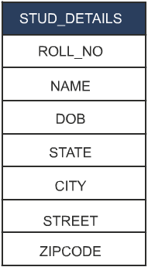
The Structure of the STUD_DETAILS Table

The STUD_DETAILS table contains the values, as shown in the following table.

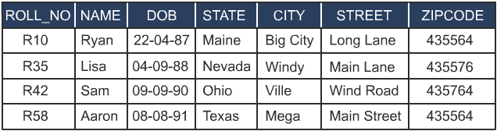
The STUD_DETAILS Table
In the preceding table, street name (STREET), city (CITY), and state (STATE) are associated with the zip code. For example, if you want to know the number of students residing at a particular location in a city, then a zip code is enough for this. Therefore, you can move attributes, STATE, CITY, STREET, and ZIPCODE into another table, ADDRESS.

The following table describes the structure of the ADDRESS table.

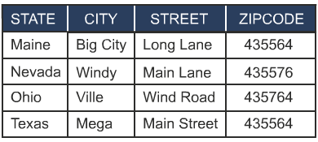
The ADDRESS Table
Then, you can move the rest of the attributes to another table, which must include ZIPCODE also.

The following table describes the structure of STUD_DETAILS.
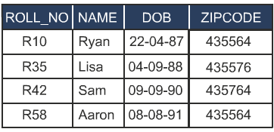
The STUD_DETAILS Table

Boyce-Codd Normal Form
The original definition of 3NF was not sufficient in some situations. It was not satisfactory for the tables:
- That had multiple candidate keys.
- Where the multiple candidate keys were composite.
- Where the multiple candidate keys overlapped (had at least one attribute in common).
Therefore, a new normal form named BCNF was introduced. In tables, where the preceding three conditions do not apply, you can stop at the third normal form. In such cases, 3NF is the same as BCNF.
A relation is in BCNF if and only if every determinant is a candidate key.
Guidelines for Converting a Table to BCNF
The guidelines for converting a table to BCNF are:
- Find and remove the overlapping candidate keys. Place the part of the candidate key and the attribute it is functionally dependent on, in a different table.
- Group the remaining items into a table.

Consider the following PROJECT table.

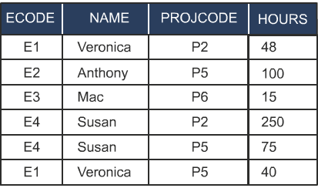
The PROJECT Table
The preceding table has redundancy. For example, if the name of an employee is modified, the change will have to be made consistent across the table, otherwise there will be inconsistencies.
ECODE+PROJCODE is the primary key of the PROJECT table. You will notice that Name+ProjCode could be chosen as the primary key and hence, is a candidate key.
The following points describe the functional dependencies in the PROJECT table:
- Hours is functionally dependent on ECode+ProjCode.
- Hours is also functionally dependent on Name+ProjCode.
- Name is functionally dependent on ECode.
- ECode is functionally dependent on Name.
You will notice that the PROJECT table has:
- Multiple candidate keys that are ECode+ProjCode and Name+ProjCode.
- Composite candidate keys.
- Candidate keys that overlap since the attribute PROJCODE is common between the two candidate keys.
This is a situation that requires conversion to BCNF. The table is essentially in the third normal form. The only non-key item is HOURS, which is dependent on the whole key, ECODE+PROJCODE or NAME+PROJCODE.
ECODE and NAME are determinants since they are functionally dependent on each other. However, they are not candidate keys by themselves. As per BCNF, the determinants have to be candidate keys.
Hence, remove Name and ECode and place them in a different table. You will arrive at the following tables.

EMPLOYEE |  |  | PROJECT
ECODE | NAME |  | ECODE | PROJCODE | HOURS
E1 | Veronica |  | E1 | P2 | 48
E2 | Anthony |  | E2 | P5 | 100
E3 | Mac |  | E3 | P6 | 15
E4 | Susan |  | E4 | P2 | 250
 |  |  | E4 | P5 | 75
 |  |  | E1 | P5 | 40
The Tables in BCNF


Just a minute:
Which one of the following methods is used to break down complex table structures into simple table structures by using certain rules?
- Normalization
- Denormalization
- Generalization
- Specialization

Answer:
1. Normalization



Just a minute:
In which normal form, you need to remove non-key attributes that are functionally dependent on non-primary key attributes?
- First normal form
- Second normal form
- Third normal form
- Boyce-Codd normal form
Answer:
- Third normal form

</print>
<epub>
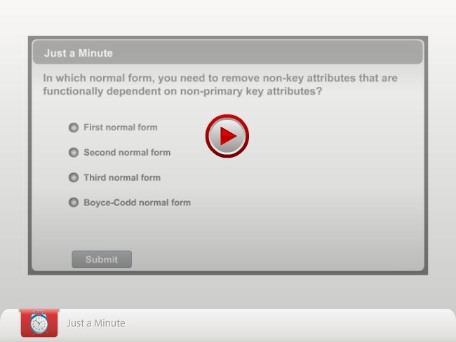
</epub>
Understanding Denormalization
After normalization, you get a set of related tables that forms the database. However, sometimes, you have to join multiple tables to get a simple output. This affects the performance of a query. In such cases, it is wiser to introduce a degree of redundancy either by introducing extra columns or extra tables.

Definition of Denormalization
The intentional introduction of redundancy in a table in order to improve performance is called denormalization.
For example, consider the following tables, ORDERS and PRODUCTS.

ORDERS |  |  |  | PRODUCTS
ORDERNO | PRODUCTID | QTY |  | PRODUCTID | PRODUCT DESC | COST
101 | P1 | 2 |  | P1 | Superheroes | 20
102 | P3 | 1 |  | P2 | Toy Guns | 10
103 | P1 | 1 |  | P3 | Soft Toys | 12
104 | P2 | 3
105 | P2 | 2
The ORDERS and PRODUCTS Tables
The preceding ORDERS table consists of order number, product id, and quantity of the product, whereas the PRODUCTS table consists of product id, description of the product, and product cost.
In case, if a shopkeeper wants to calculate the total sales of his shop, he can use the following query:

SELECT SUM((cost*qty)+(0.10*cost*qty)) FROM Orders JOIN Products ON Orders.ProductId = Products.ProductId
The preceding query includes the cost of the product and sales tax of 10% (0.10) on the product cost.
If there are thousands of rows, the server will take a lot of time to process the query and return the results as there is a join and computation involved. Hence, to speed up the processing of the query, you may want to store the cost of each order along with the tax, as shown in the following table.

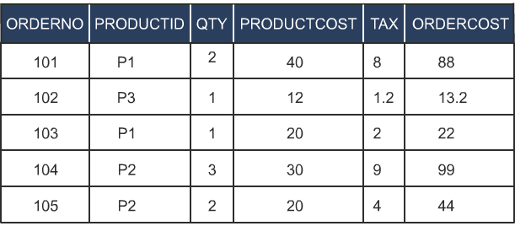
The ORDERS Table
Now, to find out the total sales made, you would have to issue the following query:

SELECT SUM (OrderCost) FROM Orders
The preceding table structure has simplified the query and enhanced the processing of the query. By storing extra columns, you are introducing redundancy in the table but improving the performance of queries.
The decision to denormalize will obviously result in a compromise between performance and data consistency. Denormalization also increases disk space utilization.

<print>
Just a minute:
The intentional introduction of redundancy in a table in order to improve performance is called ________________.
Answer:
Denormalization

</print>

<epub>

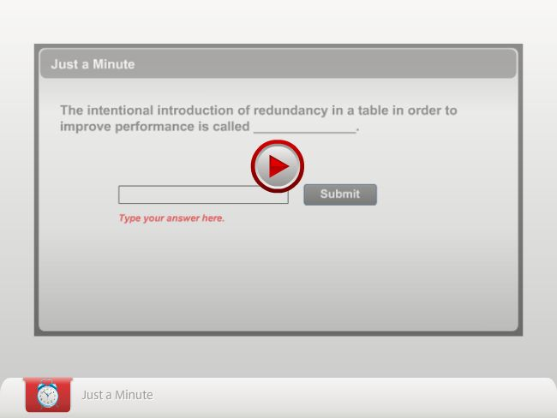

</epub>
Practice Questions
- Which of the following rules should be followed to create a good database design? (Can have multiple answers)
  - Each table should have an identifier.
  - Columns that accept NULL values should be avoided.
  - Each table should store data for multiple types of entities.
  - The repetition of values or columns should be avoided.
- Which of the following statements are the consequences of redundancy? (Can have multiple answers)
  - Update anomalies
  - Improved database performance
  - Inconsistencies
  - Unnecessary utilization of extra disk space
- What is the term used for the relations, which are created by technically splitting a table to minimize data redundancy and prevent modification anomalies?
  - Normalization
  - Denormalized forms
  - Normal forms
  - Denormalization
- Consider the following Project table.
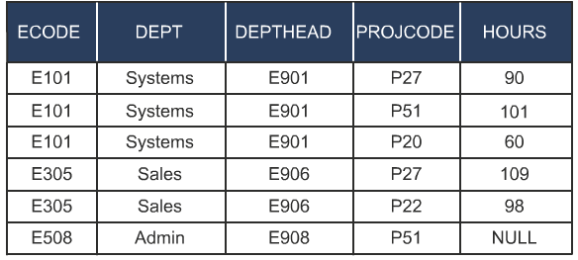
The Project Table
Identify the normal form applicable for the preceding table.
- 1NF
- 2NF
- 3NF
- BCNF

- What is the alternate term used for transitive dependency?
- Partial dependency
- Functional dependency
- Indirect dependency
- Direct dependency

Summary
In this chapter, you learned that:
- Normalization is used to simplify table structures.
- Normalization results in the formation of tables that satisfy certain specified constraints, and represent certain normal forms. The normal forms are used to ensure that various types of abnormalities and inconsistencies are not introduced in the database. A table structure is always in a certain normal form.
- The most important and widely used normal forms are:
- 1NF
- 2NF
- 3NF
- BCNF
- A table is said to be in 1NF when each cell of the table contains precisely one value.
- The following dependencies are found in normalization:
- Functional
- Partial
- Transitive
- A table is said to be in 2NF when it is in 1NF, and no partial dependency exists between non-key attributes and key attributes.
- A relation is said to be in 3NF if and only if it is in 2NF, and no transitive (indirect) dependency exists between non-key attributes and key attributes.
- A relation is in BCNF if and only if every determinant is a candidate key.
- The intentional introduction of redundancy in a table in order to improve performance is called denormalization.
- The decision to denormalize will result in a compromise between performance and data integrity.
- Denormalization increases disk space utilization.

Exercises
Exercise 1
Consider the following Product table.
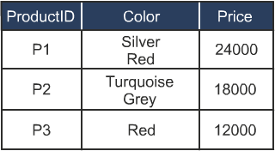
The Product Table
The preceding table is not normalized. How can this table be converted into the first normal form?
Exercise 2
Each time the salary slip for an employee is generated, the referral bonus (if present) has to be calculated and printed in the salary slip. The following tables are used for solving the preceding query.
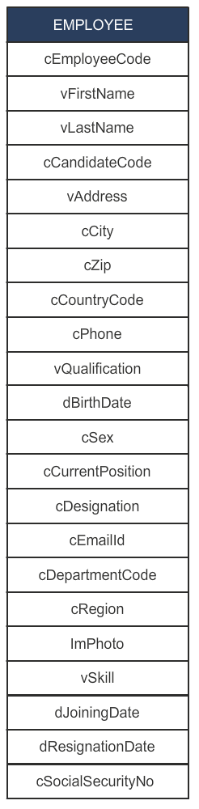
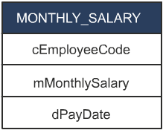
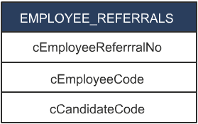
The Tables
Though the table structures are large, it is necessary to improve the performance of this query by modifying the table structures. Identify how to increase the performance of queries.
Exercise 3
New Heights is a training institute that provides courses on various nontechnical subjects, such as personality improvement and foreign languages. Xuan, the Database Designer, has made the following relations to represent the data about students, batches, and modules covered in the batches:
- STUD-ID: Student’s id (unique)
- NAME: Name of student
- BATCH-NO: Batch number (one student can belong to only one batch)
- SLOT: Time and day when the batch of students attends the class
- MODULE: Module or subject (one batch will do several modules)
- MARKS: Marks obtained in a module test
Xuan now needs to simplify the above relations by normalizing them.
Exercise 4
Consider the following Purchase_Details table.
Cust_ID | StoreID | StoreLocation
C1 | S1 | Glasgow
C2 | S1 | Glasgow
C4 | S2 | Las Vegas
C5 | S4 | New York
The Purchase_Details Table
Cust_ID and StoreID make the composite primary key in the table. Identify the partial dependency in the table, if any. How can you remove the partial dependency to attain the next normal form?
Exercise 5
Consider the following Student table.
StudentID | CourseId | Faculty
S01 | C101 | Alice
S02 | C102 | Anny
S02 | C101 | Alice
S03 | C101 | Alice

The Student Table
The preceding table is in the first normal form. How can this table be converted into the second normal form?
Exercise 6
<epub>
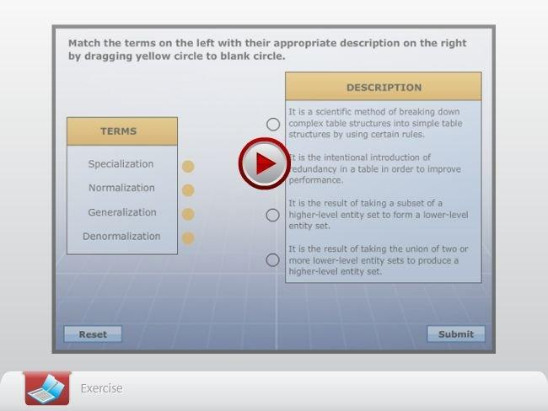</epub>
<Instruction: Embed RDBMS_03_Ex01.swf here>

